|  |
| --- |
| 2016 UAV Challenge |
| Deliverable 3: Autonomous Flight Record |

|  |
| --- |
| www.canberraUAV.org.au  August 2016 |



# Table of Contents

1 Table of Contents 1

2 Flight Operations - Pilatus Porter Quadplane 2

2.1 Flight Log Book 2

2.2 GPS Telemetry 3

2.3 Video 3

2.4 Static Images 4

3 Flight Operations - GAUI GX9 8

3.1 Flight Log Book 8

3.2 GPS Telemetry 9

3.3 Video 9

3.4 Static Images 10

4 RF Transmitters 14

4.1 2.4 GHz RC Link 14

4.2 900 MHz Telemetry Link 14

4.3 3G/4G Cellular Mobile Telecommunication Devices 14

5 Safety Case 16

5.1 Hazard One: Ground Impact 17

5.2 Hazard Two: Mid-air Collision 18

6 Aircraft Specifications and Performance 19

# Flight Operations - Pilatus Porter Quadplane

## Flight Log Book

The following is an extract of our flight logs for the VTOL Pilatus Porter Quadplane aircraft. The logs demonstrate a total of nearly 7 hours autonomous flight, with flights in excess of 30 minutes at lines 8, 10, 11, 12, 13, and 17. The logs also show a combined distance covered of 276.1 NM, with flights in excess of 11 NM at lines 7, 8, 9, 10, 11, 12, 13, 14, and 17. This satisfies the requirement specified by the Organising Committee for five hours autonomous flight; with one flight in excess of 30 minutes and one flight with a total track length in excess of 11 nautical miles.

|  | Date | Start  Time | AUTO  time | Distance (NM) |
| --- | --- | --- | --- | --- |
| 1 | 21/2/2016 | 11:34 | 1.8 | 1.5 |
| 2 | 13/3/2016 | 15:03 | 3.9 | 2.0 |
| 3 | 27/3/2016 | 11:13 | 1.2 | 1.1 |
| 4 | 27/3/2016 | 11:17 | 2.6 | 1.4 |
| 5 | 2/4/2016 | 10:36 | 2.9 | 2.0 |
| 6 | 2/4/2016 | 10:41 | 11.5 | 9.5 |
| 7 | 2/4/2016 | 12:17 | 15.8 | 12.3 |
| 8 | 10/6/2016 | 10:07 | 38.8 | 27.4 |
| 9 | 10/6/2016 | 13:16 | 25.5 | 16.9 |
| 10 | 12/6/2016 | 09:40 | 32.6 | 25.9 |
| 11 | 12/6/2016 | 11:29 | 32.4 | 23.3 |
| 12 | 25/6/2016 | 10:33 | 47.2 | 34.9 |
| 13 | 25/6/2016 | 12:39 | 41.8 | 32.4 |
| 14 | 26/6/2016 | 11:12 | 19.5 | 14.8 |
| 15 | 3/7/2016 | 12:16 | 13.0 | 8.9 |
| 16 | 8/7/2016 | 10:21 | 15.0 | 10.2 |
| 17 | 8/7/2016 | 15:17 | 43.8 | 33.9 |
| 18 | 9/7/2016 | 13:38 | 4.0 | 2.4 |
| 19 | 16/7/2016 | 12:15 | 14.4 | 7.6 |
| 20 | 17/7/2016 | 13:35 | 13.7 | 7.6 |
| 21 | 24/7/2016 | 13:35 | 3.1 | 1.6 |
|  |  |  | **06:45.00** | **276.1 NM** |

Full flight logs are available at: <https://drive.google.com/open?id=0BxJBg_6KSZ5zenVCTXF5bHVHNDQ>. They contain the full GPS tracks (in kml and gpx format) and flight telemetry (in tlog format).

## GPS Telemetry

A rendering of the gpx log from a flight on 25/06/2016 is shown below:

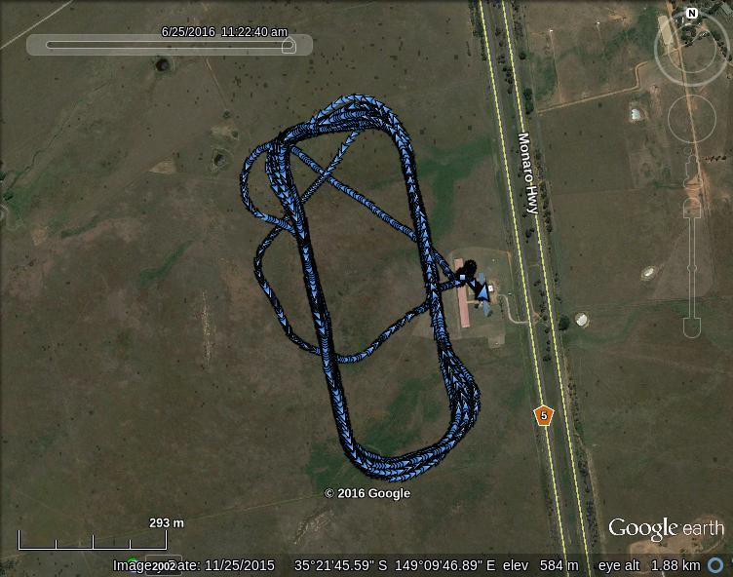

The full file is available at: <http://uav.tridgell.net/OBC2016/D3/PorterQuad-2016-06-25-flight5-AUTO2.tlog.gpx>.

## Video

A video showing the aircraft during autonomous flight and the operational ground station is available at: <https://youtu.be/yL-JBLVGdfo>. The operational ground station is shown configured for use at our local flying field (Canberra Model Aero Club). The same hardware and software system will be operated from within a vehicle at Dalby.

## Static Images

The following is a set of static images showing the ground station, aircraft and team members during flight operations from a number of flights over the last 3 months.

|  |  |
| --- | --- |
|  | Pre-flight setup |
|  | Pre-flight setup |
|  | Pre-flight team briefing |
|  | Aircraft setup |
|  | Pre-flight checks |
|  | Collecting blood (or biscuit) sample |
|  | Approach to landing |
|  | Ground station test |
|  | Mid-way through vertical landing |
|  | Landing |

# Flight Operations - GAUI GX9

## Flight Log Book

The following is an extract of our flight logs for the GAUI GX9 helicopter. The logs show over 5 hours of autonomous flight, with flights in excess of 30 minutes at lines 11, 14, and 19. The logs also show a combined distance covered of 166.8 NM, with flights in excess of 11 NM at lines 11, 14, 17, 18, 19, and 20. This satisfies the requirement for five hours autonomous flight; with one flight in excess of 30 minutes and one flight with a total track length in excess of 11 nautical miles.

|  | Date | Start  Time | AUTO  Time | Distance (NM) |
| --- | --- | --- | --- | --- |
| 1 | 19/3/2016 | 14:00 | 1.0 | 0.0 |
| 2 | 19/3/2016 | 14:39 | 1.0 | 0.0 |
| 3 | 31/3/2016 | 09:05 | 5.0 | 0.6 |
| 4 | 31/3/2016 | 09:11 | 2.1 | 0.1 |
| 5 | 31/3/2016 | 09:20 | 3.7 | 0.4 |
| 6 | 31/3/2016 | 09:31 | 2.6 | 0.3 |
| 7 | 25/4/2016 | 11:44 | 4.2 | 1.7 |
| 8 | 25/4/2016 | 11:50 | 7.4 | 4.2 |
| 9 | 25/4/2016 | 13:14 | 16.9 | 10.8 |
| 10 | 17/5/2016 | 16:00 | 9.3 | 4.0 |
| 11 | 21/5/2016 | 10:52 | 30.1 | 16.3 |
| 12 | 21/5/2016 | 12:42 | 22.4 | 2.0 |
| 13 | 22/5/2016 | 13:00 | 18.2 | 3.2 |
| 14 | 29/5/2016 | 11:45 | 31.7 | 19.6 |
| 15 | 13/6/2016 | 12:21 | 1.5 | 0.0 |
| 16 | 18/6/2016 | 13:52 | 18.4 | 10.9 |
| 17 | 19/6/2016 | 11:37 | 29.3 | 19.9 |
| 18 | 25/6/2016 | 10:09 | 20.5 | 12.0 |
| 19 | 25/6/2016 | 13:26 | 45.3 | 32.5 |
| 20 | 26/6/2016 | 15:42 | 17.1 | 11.0 |
| 21 | 3/7/2016 | 14:12 | 13.1 | 6.9 |
| 22 | 9/8/2016 | 12:42 | 20.0 | 10.4 |
|  |  |  | **5:21.00** | **166.8 NM** |

Full flight logs are available at: <https://drive.google.com/open?id=0BxJBg_6KSZ5zenVCTXF5bHVHNDQ>. They contain the full GPS tracks (in kml and gpx format) and flight telemetry (in tlog format).

## GPS Telemetry

A rendering of the gpx log from a flight on 25/6/2016 is shown below:

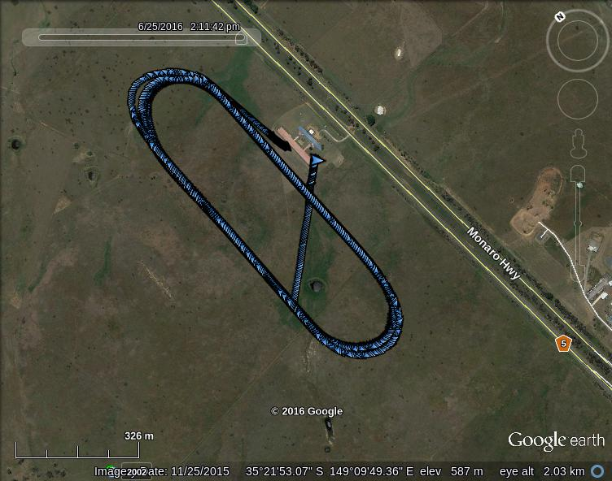

The full file is available at <http://uav.tridgell.net/OBC2016/D3/GX9-2016-06-25-flight1-AUTO1.tlog.gpx>.

## Video

A video showing the aircraft during autonomous flight and the operational ground station is available at <https://youtu.be/yL-JBLVGdfo>. The operational ground station is shown configured for use at our local flying field (Canberra Model Aero Club). The same hardware and software system will be operated from within a vehicle at Dalby.

## Static Images

The following is a set of static images showing the ground station, aircraft and team members during flight operations from a number of flights over the last 3 months.

|  |  |
| --- | --- |
| C:\Users\Stephen\AppData\Local\Microsoft\Windows\INetCache\Content.Word\26466399394_eb62f254a2_z.jpg | Pre-flight team briefing |
|  | Fuelling the helicopter before flight |
|  | Aircraft setup |
|  | Pre-flight checks |
|  | Takeoff |
| C:\Users\Stephen\AppData\Local\Microsoft\Windows\INetCache\Content.Word\27316311084_d7324a4d9d_o.jpg | Landing |
|  | Ground station test |
|  | Beginning of landing sequence |
|  | Landing |
|  | Landing |

# RF Transmitters

## 2.4 GHz RC Link

This link is used for manual RC control of the UAV’s throttle and flight control surfaces.

|  |  |
| --- | --- |
| Specification | Value |
| Model | FrSky Taranis 2.4 GHz (using a FrSky X9D internal transmitter module) |
| Transmission frequency | 2400 – 2483.5 MHz |
| Transmitter power | 60 mW (17 dBm) |
| Transmitter antenna gain | < 5 dBi |
| Calculated EIRP | < 23 dBm |
| Covering licence | Radio-communications (Low Interference Potential Devices) Class Licence 2000. Part 45A, 53, 54 |

## 900 MHz Telemetry Link

This is a low bandwidth link for transmitting telemetry from each Unmanned Aircraft to the Ground Station. Commands can be sent from the Ground Station to UAV when necessary. They have been calibrated and tested for LIPD-2000 (Part 52) compliance by RFDesigns RF lab in Brisbane.

|  |  |
| --- | --- |
| Specification | Details |
| Model | RFD900P/X Telemetry Radio |
| Transmission Frequency | 915 – 928 MHz, 20 Channel Hopping |
| Transmitter Power | 27 dBm (UAV) 24 dBm (Ground) |
| Transmitter antenna gain | 3 dBi (UAV) 6 dBi (Ground) |
| Calculated EIRP | 30 dBm (UAV) 30 dBm (Ground) |
| Covering licence | Radio-communications (Low Interference Potential Devices) Class Licence 2000, Part 52 |

## 3G/4G Cellular Mobile Telecommunication Devices

Each aircraft will carry two wireless modems to facilitate redundancy for data transfer between the ground station and each aircraft using the terrestrial mobile telecommunications network. The two modems on each aircraft will operate using different network providers to ensure maximum coverage is achieved and reduce the risk of loss of service.

|  |  |
| --- | --- |
| Specification | Details |
| Model | ZTE MF823 (Telstra) |
| Transmission Frequency | 3G 850 MHz (824-849 MHz, 869-894 MHz) |
| Transmitter Power | 24 dBm |
| Transmitter antenna gain | 2 dBi (UAV) 5 dBi (Ground) |
| Calculated EIRP | 26 dBm (UAV) 29 dBm (Ground) |
| Covering licence | Radio-communications (Cellular Mobile Telecommunications Devices) Class Licence 2014 |

|  |  |
| --- | --- |
| Specification | Details |
| Model | Huawei E3372 (Optus) |
| Transmission Frequency | 3G 900 MHz (880-915 MHz, 925-960 MHz) |
| Transmitter Power | 24 dBm |
| Transmitter antenna gain | 2 dBi (UAV) 5 dBi (Ground) |
| Calculated EIRP | 26 dBm (UAV) 29 dBm (Ground) |
| Covering licence | Radio-communications (Cellular Mobile Telecommunications Devices) Class Licence 2014 |

# Safety Case

Managing risks to people, property, aircraft and reputation is a key consideration for CanberraUAV. Since its formation in 2011, CanberraUAV has never experienced any major incidents that have caused damage to people or property. As we deal with experimental UAV technology, we acknowledge and accept that there will be equipment failures, and resulting loss or damage to airframes, but have implemented robust flight test readiness reviews and post analysis procedures to identify and resolve the causes of problems. This ensures that as hazards are identified or realised they are understood and not repeated.

CanberraUAV conducts its operations in compliance with Civil Aviation Safety Regulations Part 101 and in compliance with rules and procedures set down by the Model Aeronautical Association of Australia and the Canberra Model Aircraft Club, the club where most of our developmental flights occur. Operating large UAVs with internal combustion engines and/or high capacity lithium batteries is inherently dangerous. All members of CanberraUAV are aware of this, and that they individually and collectively owe a duty of care to others to reduce risks to the maximum extent possible. CanberraUAV’s excellent safety record over an extended period demonstrates its ability to successfully manage risk.

As part of the Deliverable 2 submission, CanberraUAV identified what it considers to be the key potential risks associated with operating its UAVs at the 2016 UAV Challenge, along with the treatment measures it has implemented to manage those risks. As part of Deliverable 3, the Technical Committee has asked that teams specifically address their approach to managing two particular hazards:

* ground impact of the UAV, where the Entities of Value (EOVs) are: people, property, livestock, and crops, and
* mid-air collision, where EOVs are other airspace users.

In making its safety case for these hazards, CanberraUAV has chosen a high-level Barrier-Bow-Tie (BBT) framework[[1]](#footnote-1) - a graphical representation of the BBT framework is shown at Figure 1. The preventative barriers are defences that have been put in place to reduce the likelihood of the hazard state being realised – the mitigative barriers are defences that have been put in place to reduce the likelihood of the hazard state transitioning to an accident state.

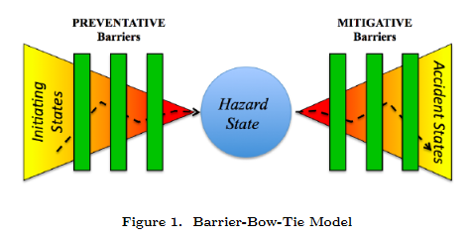

## Hazard One: Ground Impact

And the potential to cause damage to EOVs.

|  |  |
| --- | --- |
| Preventative Barriers | Mitigative Barriers |
| System reliability  - airframes have been extensively tested in a variety of weather conditions  - flight envelope of airframes has been modelled and extensively tested, with reinforcement applied in necessary areas  - individual primary responsibility for the maintenance of individual aircraft with regular preventative maintenance and replacement of suspect components  - flight controller software is developed and thoroughly tested by experienced software engineers  Flight controller has redundant sensors and attitude estimation algorithms  - extensive hours of simulated testing has occurred on a variety of aircraft types operating in varied conditions | **Impact**  - the event is located in a sparsely populated area where the risk of damage to persons and property is already low  - strict geo-fences are implemented to prevent flights outside of the mission area and the aircraft will terminate flight if the geo-fence boundary is breached |
| Terrain avoidance  - terrain following is implemented in the flight control algorithms, with additional checks conducted during flight planning using knowledge collected about the areas to be overflown.  - additionally, an on-board Lidar gives centimetre accurate height above ground level, which is displayed at the ground station. This is monitored and corrective action can be taken if required | **Energy Management**  - the aircraft have only a moderate mass and are built from a combination of balsa (for the Porter) and carbon-fibre and metal (for the GX9)  - fuel will be carried in commercially available burst-proof tanks  - lithium batteries will be secured in fire resistant shrouds and be in good condition reducing the likelihood of a fire  - ground risks at the launch site are managed with the use of a portable safety kit with fire extinguisher |
| UAV Controller  - highly skilled and experienced pilots with heavy model certification will be able to assume control of the UAV if in visual range  - the UAV Controllers will be well rested, and drug and alcohol free | **Exposure**  - the arrangements already in place – i.e. operating in a remote location, during the day, out of high winds with prior notification of the public already provide significant mitigation |
|  | **Loss intervention**  - the extensive testing - through simulation and flight testing - that has been undertaken by CanberraUAV have led to the development of mature emergency response strategies  - team members have a good understanding of their respective roles and are able to react quickly to incidents |

The overall potential for loss to EOVs as a result of ground impact is considered to be low. The magnitude of any potential loss is also considered to be low.

## Hazard Two: Mid-air Collision

And the potential to cause damage to EOVs.

|  |  |
| --- | --- |
| Preventative Barriers | Mitigative Barriers |
| Separation provisions  - there will be approximately 3 minutes separation between the two aircraft used to complete the mission to reduce the likelihood of one aircraft colliding with the other  - there will also be altitude separation between our two UAVs throughout the mission to provide further assurance  - the aircraft will always remain well below 1500 ft AGL as specified in the rules document  - at all times throughout the mission, the aircraft will remain inside the designated mission area, and the geo-fence failsafe arrangements will also apply if the UAVs breach the altitude restriction for any reason (however it is likely that corrective action will have already been taken by that time) | **Damage mitigation**  - the MTOW of both aircraft to be used in the mission is less than 17% of the maximum allowed, reducing impact damage compared to that caused by a UAV operating at 100% allowable MTOW (100 kg rotary wing/hybrid or 150kg traditional fixed wing) |
| Conflict management  - we understand a NOTAM will be issued for the area during the event and that radio frequencies will be monitored by the Technical Committee  - ground station operators and the remote pilots are able to take immediate action and dive the aircraft if within visual range or if notified of a danger by the Technical Committee  - both aircraft are able to be commanded to descend (or if required terminate) to a lower flight level if required. We will liaise closely with the Technical Committee to monitor local traffic. | **Loss mitigation**  - if there are concerns at any stage during the mission, for instance a light aircraft is observed or reported approaching the mission area, both aircraft will be directed to as low as practicable altitude where separation will be maintained by the ground station operator. The flight(s) will be terminated in a safe manner if directed by the Technical Committee |
| Collision avoidance  - high visibility tape will be applied to the aircraft to improve visibility to the extent possible  - we also hope to integrate an ADSB receiver at the ground station to provide independent early warning of nearby air traffic approaching the mission area |  |

The overall potential for loss to EOVs as a result of a mid-air collision is considered to be very low. The magnitude of any loss is considered to be low.

In addition to the above safety system, CanberraUAV implements the full OBC failsafe system as detailed in our Deliverable 2 document. That system is implemented as features in the autopilot and ground station system, providing geo-fencing, pressure altitude limits, and state handling for loss of GPS and telemetry. Together, the features of the failsafe system ensure that the vehicle will remain within the designated flight area.

# Aircraft Specifications and Performance

Canberra UAV has developed two airframes for the 2016 UAV Challenge. Each airframe has a backup and the final combination to be used in performing the mission is yet to be determined. The aircraft have the following specifications:

**Fixed wing hybrid ‘Quadplane’ - VQ Models Pilatus Porter PC-6**

|  |  |
| --- | --- |
| Specification | Details |
| Maximum Airspeed | 60 kts |
| Cruise Airspeed | 54 kts |
| Endurance at maximum airspeed | Estimated 70 minutes |
| Endurance at cruise airspeed | 80 minutes |
| Maximum take-off weight | 16 kg |
| Competition take-off weight | 14 kg |
| Wingspan | 2720 mm (107 in) |
| Airframe length | 2000 mm (78.7 in) |
| Identifying marks | White wings with red trim on the fuselage |
| Aircraft platform and configuration | High wing aircraft/H8 multirotor hybrid |

**Rotary wing - GAUI GX9**

|  |  |
| --- | --- |
| Specification | Details |
| Maximum Airspeed | 58 kts |
| Cruise Airspeed | 52 kts |
| Endurance at maximum airspeed | Estimated 105 minutes |
| Endurance at cruise airspeed | 120 minutes |
| Maximum take-off weight | 19 kg |
| Competition take-off weight | 12 kg |
| Main rotor diameter | 1800 mm (70.8 in) |
| Tail rotor diameter | 260 mm (10.2 in) |
| Airframe length | 1768 mm (70.4 in) |
| Identifying marks | Light grey with red and black trim |
| Aircraft platform and configuration | Helicopter on landing skids |

1. Further information on the BBT Model can be found at: <http://www.sciencedirect.com/science/article/pii/S0925753515001496> [↑](#footnote-ref-1)